## BREAKING



**You could start your day with savings**

Ad By Progressive

See More

**Developer reflects Dudley Square’s**

**renaissance**

At 90, developer Kenneth Guscott offers a glimpse of the past, present, and future of Dudley Square

**By Meghan E. Irons** Globe Staff, March 22, 2015, 12:35 a.m. **15**



*Illuminating Eye Cream*

1,800 Amazon.com customer reviews

“I totally recommend!!!”

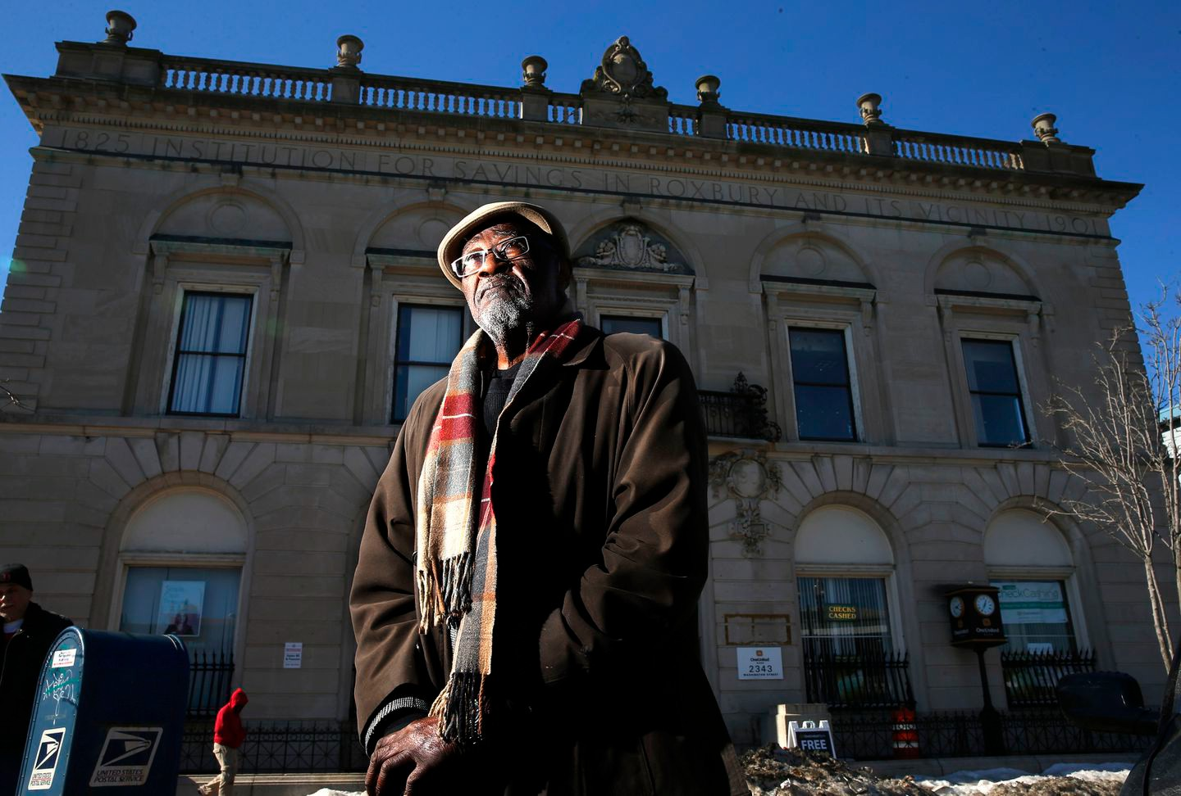

Kenneth Guscott, a developer in Dudley Square. JESSICA RINALDI/GLOBE STAFF

Kenneth Guscott came of age when Dudley Square was still at its peak, when the aisles at Blair’s Foodland brimmed with people, the Ferdinand furniture store flourished, the food stands overflowed with oranges and lemons.

Teenagers paid 10 cents to see cowboy shoot-’em-up films at one of the square’s three movie theaters. Nighttime brought revelers to the Irish dance halls. The El rumbled overhead, ferrying shoppers to the tailors, bakers, jewelers, and butchers along Washington and Warren streets.

At its prime, Dudley Square was the second-busiest commercial district in Boston, after downtown. And it was the epicenter of the black community.

Advertisement

## BOSTON GLOBE VIDEO

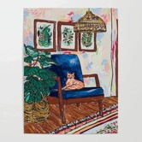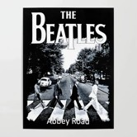

2:23

Baker announces ‘VaxM SHARE

Governor Charlie Baker announced residents who are fully vaccinated against COVID-19 will have the chance to win $1 million in a special Lottery sweepstakes. (Photo by Matt Stone/Boston Herald via AP)

But as Guscott turned 15, the 1940s swept in a period of uncertainty, leaving Dudley’s residents clinging to a prosperity that would dissipate.

**s ns’**

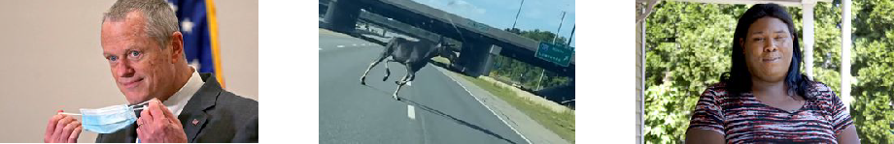

**NOW PLAYING**

**Baker Moose What announce spotted Black ‘VaxMillio on liberation lottery Route 3 means program in to me:**

**Chelmsfo Athena**

**Vaughn**

Now, as Guscott enters his 90s, his deep connection to Dudley Square offers a glimpse of the triumphs, demise, and promised resurgence that consumed Roxbury’s main commercial district and the people living nearby.

**rd**

# Get Today's Headlines in your inbox

The day's top stories delivered every morning.

Enter Email

[example@email.com](mailto:example@email.com) **Sign Up**

With Guscott in his twilight, the rebirth **Related**

of the old neighborhood finally appears

to be taking hold. The landmark Ferdinand building is rebuilt and

**Bolling Building an architectural gem in Roxbury**

buzzing. A new Tropical Foods store is bustling with customers. Housing values are rising. And, nearby, the planned Tremont Crossing project would bring a hotel, residences, offices, and retail.

Guscott still waxes nostalgic about the Roxbury of old — the days of glory, heralded in the autobiography of Malcolm X, who lived near the square in the 1940s and early ’50s. Their Roxbury had neon lights, entertainment halls, and restaurants that made the streets smell like down-home cooking.

But by the late 1960s, many businesses were gone. And in the years that followed, Dudley Square was never the same.

**MOST POPULAR ON BOSTONGLOBE.COM**

1. 5 things to know about the VaxMillions lottery sweepstakes in Mass.
2. Baker announces ‘VaxMillions’ lottery program, offering $1 million cash prizes to boost vaccination rates
3. The downside of ditching masks: the return of colds, flu
4. Message in a bottle, tossed into the sea in Rhode Island, found in Azores
5. America's blind spot: Thousands of drivers shouldn't be licensed
6. I got the Johnson & Johnson vaccine. The pause makes me believe in it more.
7. Patriots’ Dont’a Hightower is at minicamp to play football, and he can’t be any clearer
8. The case for prosecuting Donald Trump
9. A treasure map for an American tyrant
10. Summer Reading 2021

“When we were youngsters, Dudley Square was the heart of the black community,” Guscott recalled. “We went to war, got back. We went to college and got back. Dudley had died down.”

Advertisement

The population boom that marked the latter part of the 19th century was rapidly dwindling. Roughly 60,000 people left Roxbury from 1950 to 2000, according to city data.

An examination of the past 70 years in Dudley shows a community trying to lift itself from the crippling grip of population flight, neglect by absentee landlords, and discriminatory government practices.

Residents and advocates have long fought to return Dudley to its days of yore. Newspaper headlines from as far back as 1975 expressed optimism, screaming of a revival that never came. An article in 1985 told of city plans to



Kenneth L. Guscott in 1954. HANDOUT

spend $750 million to turn Roxbury into a showplace of “shopping galleries, tree-lined boulevards, and new industrial office complexes.”

But it has been a long, hard road, with progress coming in fits and starts.

“Everyone [goes] back to the first half of the 20th century — that’s the golden age of Dudley Square,” said David Price, executive director of Nuestra Comunidad Development Corporation, which is redeveloping an old MBTA site just outside the square. “Everyone is trying to get back there.”

# A changing neighborhood

Guscott was raised on Shawmut Avenue, one of the tiny veins that feed into Dudley Square. His Jamaican-born parents were part of the new wave of immigrants settling into apartments once occupied by Irish, Italian, and Jewish residents.

His mother used to walk to the employment office in the square — bordered by Washington, Warren, and Dudley streets — to get a day’s work washing clothes for families in Mattapan for 25 cents an hour. On Saturdays, she hauled her five boys to the parking lot at the old Woolworth’s to protest its lack of minority workers.



**VIEWS FROM OUR COLUMNISTS**

**YVONNE ABRAHAM**

Energy efficiency is a low- hanging fruit to combat climate change. So why can’t everyone get access to it?

**KEVIN CULLEN**

Bill Bratton on American policing and the challenge facing the Boston Police Department

**THOMAS FARRAGHER**

A salute across the ages to an old squad leader

**SHIRLEY LEUNG**

A working mother’s manifesto: Pandemic provides a once-in-a- generation chance to course correct how we work

**JENEÉ OSTERHELDT**

Juneteenth and the meaning of Black liberation in Boston

**ADRIAN WALKER**

‘The best Boston movie no one’s ever seen’: ‘Blue Hill Avenue’ at 20

Advertisement

As a young boy, Guscott would hear from representatives of the square’s Boston Five Cents Savings Bank who came to his school to teach students about saving money. As a man, he would buy that bank building and a few others in the square in the hopes Dudley would one day turn around.

Guscott joined the Army Air Force during World War II. All five Guscott boys served in the war. One — Charles — did not make it back.

“I wanted to be a fighter pilot. I wanted to avenge my brother’s death,” said Guscott, who began serving at 17.

The Army had one black fighter squadron, which was full when Guscott went to sign up. Instead, he served with segregated forces and later was assigned to the jungles of New Guinea. His military service done, Guscott went on to the US Merchant Marine Academy, earning a degree in marine engineering. Later, he was handpicked by Admiral Hyman Rickover, the father of the nuclear Navy, and helped build the first nuclear-powered surface ship, he said.

By the time he returned to Shawmut Avenue, Dudley Square — and Roxbury more broadly — was vastly different. The movie theaters of his youth had closed. The neighborhood was on the brink.

“Dudley was symptomatic of inner-city commercial areas all over this country that went into decline,” said David Lee, a Boston architect who designed some of Roxbury’s iconic structures, including Ruggles Station. “So when Ken and those guys got back in the mid- to late-’50s, that decline started.”

Advertisement



Small prints on a fence in Dudley Square. DAVID L. RYAN/GLOBE STAFF/GLOBE STAFF

Roxbury had been bleeding its critical mass — the white ethnic communities

— who began moving to more affluent areas of Boston or to suburban communities, traveling there on freshly paved highways.

At the same time, a new wave of migrants arrived: African-Americans fleeing the Jim Crow South looking for opportunities in the North, and immigrants from Latin America.

Unemployment was mired at double-digit levels, jobs were scarce, and crime ran rampant — problems still plaguing the neighborhood. Distrust between the community and City Hall, as well as other entities, intensified.

Moving out of the neighborhood proved hard for many blacks. Banks refused to loan money, and real estate agents restricted where they could live, Price said.

It wasn’t until Guscott was nearing 40 that he started to take on a deeper role in the community. After the war, he and the other black veterans determined that they would not accept a segregated society. By the early 1960s, he was president of the local NAACP.

At that time, Boston was at war with itself. Protests were erupting about civil rights and lack of police protection in certain neighborhoods. Midway through the 1960s, Malcolm X was gunned down. A few years later, Martin Luther King Jr. was assassinated. Riots rocked the city.

Advertisement

At the time, Mayor Kevin H. White urged Guscott to join a committee to determine the causes of the unrest. People were angry about the lack of jobs and affordable housing, the committee reported back.

Panel members then worked with officials from the US Department of Housing and Urban Development, providing input about a new subsidy program called Section 8.

Guscott figured the initiative would be a boon for the community, but he noticed that construction jobs for HUD-funded projects went to workers from outside Roxbury. Outsiders were also using federal money to buy up Roxbury’s deteriorating buildings.

Guscott and his brothers Cecil and George were incensed. They formed Long Bay Management Co. in 1969 and began purchasing properties, becoming a force in the real estate market. They bought residential and commercial buildings, including the OneUnited Bank site — the former Boston Five Cents Savings Bank — in Dudley Square.

They also bought one of the buildings that shared the same site as the Ferdinand, with hopes of rebuilding.

He and his brothers stayed in the square even as the economy plummeted, city plots sat idle, and residents and entrepreneurs fled.

“We said we are going to do our share of development,” Guscott said. “We aren’t going to sit by and let those . . . folks develop it.”

# Community activism rises

By the time the 1970s rolled in, the city had razed vast sections of land in Roxbury for a failed highway project.

Arson cases spiked as rogue landlords set properties afire to cash in. Roxbury’s more affluent black residents began to move out in droves, with city data showing the population declined 30 percent in the decades since 1970. Guscott and his young family moved to Mattapan in the 1960s, becoming the first African-Americans on their street.

At the same time, community activism raged, particularly in a neighborhood where political leadership had been scant. In 1951, Roxbury elected an African-American city councilor — but the City Council refused to seat Lawrence Banks after he defeated Roxbury’s white councilor, Daniel F. Sullivan.

The council then revised the city charter to eliminate its ward system and institute at-large council seats instead. For two more decades, not one black person was elected to serve, stifling Roxbury’s voice in City Hall.

“I don’t think we had a critical mass to effectively challenge what was happening at the State House and City Hall,” said City Councilor Charles Yancey, who grew up in Roxbury.

Without help from City Hall, advocacy came from living rooms, community centers, and church pews. It came from parents tired of second-rate schools, workers unable to get jobs, and residents unable to get basic city services.

“We were trying to get equitable resources from the city, and they basically ignored us,” said Bill Owens, Massachusetts’ first black state senator. “We didn’t have services. We didn’t have good housing. We didn’t get good garbage collection in all the black communities.”

Black state lawmakers were elected in the 1960s and ’70s, but it was not until 1971 that Roxbury’s Thomas I. Atkins, a vocal president of the NAACP who championed school desegregation, won a seat on the City Council. It would take a court challenge and another decade before Roxbury native Bruce C. Bolling was elected to the City Council in 1981.

Roxbury’s other black councilors included Garreth Saunders; Chuck Turner, whose decade-long-tenure was marred after he was convicted in a corruption scandal; and the current councilor from the district, Tito Jackson.

“I ran for office to ensure the economic rejuvenation of Roxbury, and to have this community see the bright lights of new businesses and a restoration of the economic activity that we saw in the past,’’ Jackson said.

A mural at Tropical Foods super market's old store. DAVID L. RYAN/GLOBE STAFF/GLOBE STAFF

# Waiting for renewal

After the elevated train came down in the mid-1980s, many business owners in Dudley Square expected a speedy recovery.

“Nothing happened for 10 years,” said Ronn Garry, who now owns the gleaming new Tropical Foods store. “It felt [like] everywhere else was moving, except Dudley.”

Garry’s maternal grandfather, Pasteur Medina, emigrated from Cuba and sold plantains in the old building on Washington Street. They called him El Platanero, the banana man. He established the store 40 years ago, and it became the go-to market for Latin American groceries in Boston. His son-in- law and grandsons took over the business.

The Garrys stayed in the square, waited through economic downturns, and hung on. In the meantime, the Fenway boomed, as did the Longwood Medical Area and eventually the South Boston waterfront.

“For a long time, Boston’s economic development was about downtown and not the neighborhoods,” said James Jennings, a Tufts University urban policy professor. “It was easy to overlook Dudley Square.”

Change came slowly. Low-income housing was built, along with a new police station and a post office. The old Hibernian and Palladio halls were rehabbed.

Mayor Thomas M. Menino empowered community leaders to develop a master plan for the neighborhood and help redevelop empty parcels.

By then, Guscott had targeted the old Ferdinand site, right in the heart of Dudley Square. The Guscotts’ company bought one of the structures on that property at a city auction for $24,000 in the 1970s when no one else wanted it, Guscott said.

They had three contracts to redevelop their building, and each time were blocked by politics, Guscott said. Twice, the state reneged on promises to move state agencies there — first, the Department of Transportation and, later, the Department of Public Health.

“We didn’t realize the politics that was involved,” he said. “Construction today isn’t just the bright young people building the buildings. It’s also the politicians calling the shots — even so today.”

Menino stepped in and vowed the city would revive the Ferdinand building. But he eventually took Guscott’s building and others by eminent domain.

The mayor promised it would bring jobs and housing.

# Concern for poor residents

At the old Bartlett Yard, once the site of a Massachusetts Bay Transportation Authority bus depot, plans are in the works for a Harvest Co-Op Market.

Newcomers from Somalia and Sierra Leone are setting up businesses in the square. Housing prices are soaring.

Residents again sense change on the horizon, but as talk of revival resumes, many around Dudley Square worry the poor might be edged out, a concern flaring anew as developers push plans for restaurants and night life — amenities that residents said they wanted in a recent community survey.

What’s next for Roxbury is a question now playing out over a planned hotel on a vacant city lot right outside the square.

Despite support from the committee that worked on Roxbury’s master plan, the project faces stiff opposition from a jobs coalition demanding higher wages and the ability to unionize. But the developers, including minority investors, worry the opposition might put their plan in jeopardy. The Boston Redevelopment Authority has so far failed to intervene, saying it is letting the community process play out.

In the meantime, the 90-year-old Guscott is coming out of retirement to build a major structure on the OneUnited Bank site that would include commercial, retail, and housing space. And he’s leading an African- American team, including his brother Cecil and daughter, Lisa, to develop the site in Dudley Square.

For Guscott, this is symbolic of a life that has come full circle: He is done waiting for change to come.

[Meghan E. Irons can be reached at meghan.irons@ globe.com. Follow her](mailto:MeghanE.Ironscanbereachedatmeghan.irons@globe.com.Followher) on Twitter @meghanirons.

**Correction:** Because of a reporting error, Bill Owens was misidentified in an earlier version of this article.

**Show 15 comments**

**MORE ON GLOBE.COM**

**SPONSORED BY: T. F. GREEN AIRPORT**

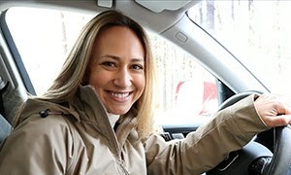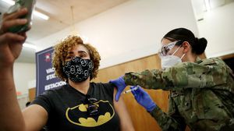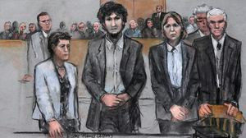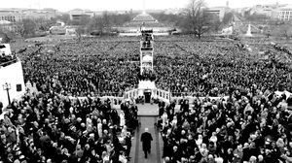

**From south of Boston, is it faster to get to Rhode Island’s**

**T. F. Green Airport or Logan?**

Many New Englanders look to Logan as their primary travel option, but is there an easier way to fly? We tested it out and were pleasantly surprised.

**The case for prosecuting Donald Trump**

Saving American democracy for the

long run requires a clear condemnation of the Trump presidency. That means making clear that no one is above the law.

**5 things to know about the VaxMillions lottery sweepstakes in Mass.**

Here are five things you should know

about the VaxMillions program, which will make some lucky winners living proof that trusting the science really does pay.

**America's blind spot: Thousands of drivers shouldn't be licensed** A Boston Globe investigation of how

bureaucratic negligence has left lethal

drivers on the road.

**RI NEWS**

**Message in a bottle, tossed into the sea in Rhode Island, found in Azores**

The note was written in 2018 by a 13-

year-old who was visiting family in Rhode Island.

**Death penalty should be reinstated for Tsarnaev in Boston Marathon bombings case, Biden administration tells Supreme Court**

The Biden administration is asking the

Supreme Court to reinstate the death penalty against Dzhokhar Tsarnaev for the Boston Marathon terror bombings.

**Baker announces ‘VaxMillions’ lottery program, offering $1 million cash prizes to boost vaccination rates**

State officials on Tuesday said

residents who’re fully vaccinated against COVID-19 will have the chance to win $1 million in a special Lottery sweepstakes.

**A treasure map for an American tyrant**

Donald Trump exposed weaknesses

that a would-be dictator could exploit to end our democracy. It’s now up to lawmakers, voters, and public officials to prevent that from happening.

**Summer Reading 2021**

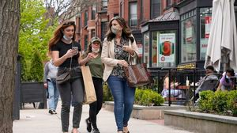

Here are 70 of the best books to pop into your travel bag.

**The downside of ditching masks: the return of colds, flu** Since the state’s mask mandate was

lifted, face coverings have started to

come off — and stay off. But according to infectious diseases doctors, the return of facial freedom might come with some downsides, like a resurgence in cases of the common cold and the flu.

**MOST READ IN THIS SECTION**

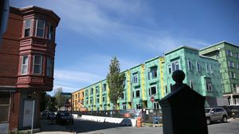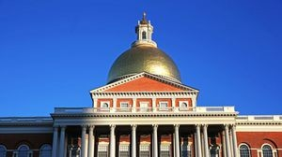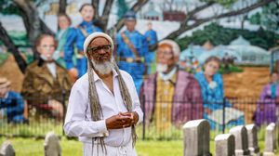

**RI NEWS**

**Message in a bottle, tossed into the sea in Rhode Island, found in Azores**

**5 things to know about the VaxMillions lottery sweepstakes in Mass.**

**Baker announces ‘VaxMillions’ lottery program, offering $1 million cash prizes to boost vaccination rates**

**America's blind spot: Thousands of drivers shouldn't be licensed**

**With housing at center of Boston mayor’s race, labor and developers are organizing to push candidates**

**Lawmakers reach compromise on restoring pandemic era-policies including to-go cocktails, outdoor dining**

**The downside of ditching masks: the return of colds, flu**

**‘Boo Boo’ the South Shore Bear captured on video roaming in Duxbury**

**How Massachusetts communities are celebrating the state’s first official Juneteenth**

**FOLLOW US**

**SUBSCRIBE NOW MY ACCOUNT CONTACT MORE**

Digital Access Home Delivery Gift Subscriptions

Log In

Manage My Account Customer Service

Help & FAQs Globe Newsroom Advertise

Newsletters / View The EPaper /

Order Back Issues / News In Education / Search The Archives / Privacy Policy / Terms Of Service / Terms Of Purchase / Work At Boston Globe Media /

Do Not Sell My Personal Information

**METRO SPORTS BUSINESS & TECH OPINION**

WELCOME, JOHN

**TODAY'S PAPER**

**Check out this week's virtual events**

RSVP now

**LAWMAKERS STRIKE DEAL TO RESTORE PANDEMIC-ERA POLICIES, INCLUDING EVICTION PROTECTIONS, TO-GO COCKTAILS**



©2021 Boston Globe Media Partners, LLC